SYLLABUS

RES 7000: Vertically Integrated Projects
Fall 2022

Course Information

Class meeting time: TBD
Modality and Location: TBD

Instructor Information

Name: xxx
Email: xxx
Office Location: xxx
Office Phone: xxx
Office Hours: xxx
Preferred method of communication: xxx

About VIP
The Vertically Integrated Projects (VIP) program is an initiative designed to facilitate large-scale interdisciplinary research projects on campuses. Graduate students who join VIP teams earn academic credit for their participation in design/discovery efforts; training, and oversight of undergraduate participants; and assisting faculty with research and development issues in their areas of expertise.
The teams are:
- Multidisciplinary – drawing students from all disciplines on campus
- Vertically-integrated – maintaining a mix of undergraduate and graduate students each semester
- Long-term – each graduate student may participate for the duration of their graduate career
The continuity, technical depth, and disciplinary breadth of these teams are intended to:
- Provide the time and context necessary for students to learn and practice many different professional skills, make substantial contributions to the project, and experience many different roles on a large, multidisciplinary VIP team.
- Support long-term interaction between the graduate and undergraduate students on the team. The graduate students mentor the undergraduates as they work on VIP projects embedded in the graduate students' research.
- Enable the completion of large-scale projects that are of significant benefit to faculty members' research programs.

Course Description
Multidisciplinary course supporting faculty research. Can participate multiple semesters. Students will have strong foundations within the discipline(s), pursue further knowledge/skills, make meaningful contributions, and assume significant technical/leadership responsibilities.

Learning Outcomes
Learning outcomes specific to each project will be developed by the Principal Investigator (PI) for each VIP project. Below are general learning outcomes for students in VIP – PIs will select the learning outcomes applicable to each student/project.
At the end of your VIP experience, you will be able to:
- Define the terminology associated with research and theory in this field
- Describe past research studies in this field of study
- Articulate how this research study makes a contribution to the field
- Explain the rationale for choosing particular research methodologies and data analytic techniques
- Evaluate research studies as part of the literature review
- Locate primary and secondary sources related to the field of study
- Synthesize and critically analyze past research in the field of study
- Design a study to answer a research question
- Develop a hypothesis
- Train undergraduate team members in relevant methodologies
- Monitor and mentor undergraduate team members
- Describe ethical research practices and apply those practices to a research study
- Write an IRB (or IACUC) proposal and become IRB certified
- Collect data for a research study
- Analyze, synthesize, organize, and interpret data from research studies
- Work effectively as part of a team
- Write a research paper
- Present your research/creative activity to an audience (e.g., poster, oral presentation, performance, display)
- Articulate the ways in which research participation helps prepare you for a postdoctoral research position and/or a career
- Describe appropriate professional conduct (e.g., at conferences, when interacting with professionals in the field)
- Reflect on your research project, including strengths, weaknesses, and things you would do differently in another research context

Course Materials

Required Texts: xxx
Recommended Texts: xxx
Technology Requirements: xxx

Course Requirements and Assignments
Below are sample requirements/assignments for a VIP course. Faculty leading VIP teams will come up with assignments specific to their projects.

#1: Notebook (Paper-based or electronic Jupyter).
- Each team member will keep a notebook on their work during the semester.
- Sample notebooks from Georgia Tech’s VIP program can be found here and could serve as a good model for your notebook: http://www.vip.gatech.edu/vip-notebooks
- Notebooks must adhere to the following guidelines:

Notebook Maintenance | - The notebook must be a bound notebook, with a sewn or glued binding, such as a composition book or lab notebook.  - Your name, your project's name, your contact info, and your team members' contact info must be recorded on the outer or inside cover.  - Each page must be numbered, dated, and signed.  - Or electronic notebook in Jupyter
To-Do List Maintenance | - Maintain check-boxes for items to be done.  - Check-off and date items when done.
Meeting Notes | - For meeting notes, include check-boxes for items for which you are responsible and deadlines for your sub team and the overall team.
Usability | - Will your VIP notebook be of use to people who join the team later and need to refer to it? This includes legibility, intelligible technical and meeting notes, and overall organization.
Overall | - An overall rating of your notebook. (Detailed design notes, design decisions, copies of or pointers to code that you wrote, records of important websites, etc.)
Wiki content | - Wiki content refers to documentation produced online, either  through the VIP wiki site, T-square, or other VIP-approved site.

#2: Conference Abstract

You will write a short abstract for your research for inclusion in the Symposium of Student Scholars. Your abstract will be graded on the extent to which you clearly articulate the following information (guidelines adapted from the National Conference on Undergraduate Research):

- Clearly state the central research question and/or purpose of the project
- Provide brief, relevant scholarly or research context (no actual citations required) that demonstrate its attempt to make a unique contribution to the area of inquiry
- Provide a brief description of the research methodology
- State conclusions or expected results and the context in which they will be discussed.

In addition, your abstract should be well written and well organized.

#3: Conference Poster

You will present your research as a poster at the Symposium of Student Scholars. Your poster will be graded according to the following rubric:
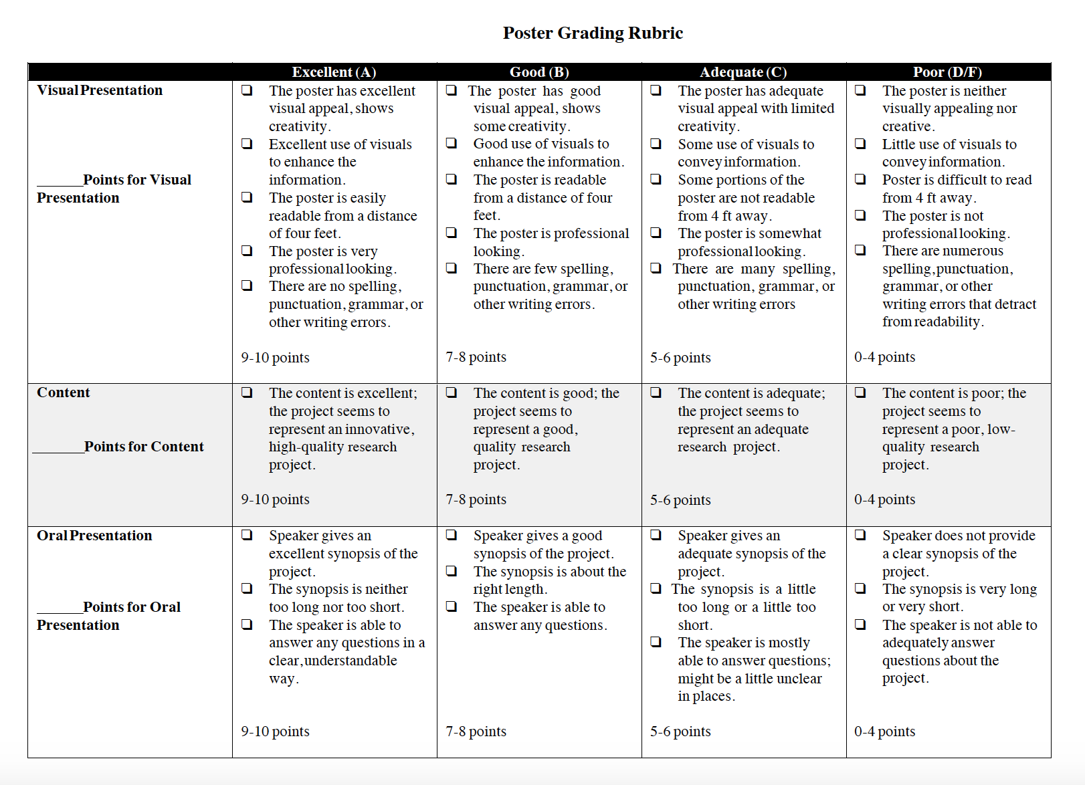

#4: Attendance and Participation

All team members must attend all team meetings and participate fully in the research experience. Periodically, the VIP coordinators will ask for information (e.g., feedback, progress reports), and these count toward your participation grade.

#5: Peer Evaluation/Mentoring

Graduate level team members will engage in undergraduate evaluations with the faculty PI, both in terms of research participation and the research products (like abstracts and posters). The forms are available in D2L. Graduate students are expected to engage in mentoring activities with the undergraduate researchers, and these efforts will be evaluated by the faculty members on the VIP team.

#6: Manuscript for Publication

Graduate students on this VIP team take the lead in co-constructing manuscripts for publication with the undergraduate researchers. It is expected that progress will be made on at least one manuscript each semester, with ideally one manuscript submitted at the end of each semester in which the graduate student is enrolled in this course.

Evaluation and Grading Policies

The premise of VIP is teams working on projects. Much like a real-world team, individual members work on different aspects of the project. Team members range from sophomores through graduate students, from first-time participants to students who have been involved for four or more semesters. The number of credits for which a student is enrolled is taken into account in grading.

Your grade is based on these areas. Although each student contributes in different ways, you must demonstrate achievements in all of these areas below.

Item | Points | Due
1) Notebook | 20 | Every Friday
2) Conference Abstract | 10 | One week before abstracts are due for the Symposium of Student Scholars
3) Conference Poster | 15 | Date of the Symposium of Student Scholars
4) Attendance and Participation | 15 | Ongoing
5) Peer Evaluation/Mentoring | 15 | Ongoing
6) Manuscript for Publication | 25 | End of the semester
Total | 100

GRADING SCALE:
90%–100% A
80%–89% B
70%–79% C
60%–69% D
0%–59% F

Course Policies
Attendance at team meetings is mandatory. Please let me know right away whether you will be unable to attend a team meeting due to an emergency.
In this class, we might engage with some material that may feel new or controversial. When someone expresses an idea, whether in writing or class discussion, it’s vital that we respect each other’s ideas and treat each other kindly. Kindness does not mean that we’ll never disagree. Instead, kindness means that when we disagree, we’ll treat each other with respect, openness, and a willingness to learn. In fact, disagreement, challenge, and vulnerability lead to the richest learning, so it’s important that we work together to create conditions where we are able to dig deep into difficult ideas instead of just scratching the surface. To be clear, opinions that threaten violence will not be tolerated in the same way. If you have any concerns about an idea that a peer has shared or feel unsafe in the classroom, please set up a time with me so we can discuss your concerns. We will work as a group to create a Ground Rules for Discussion list.

Institutional Policies & Resources

Federal, BOR, & KSU Course Syllabus Policies
Student Resources
Academic Integrity Statement

Office of Undergraduate Research Resources

As part of this VIP team, you will present your research at the Symposium of Student Scholars. You will also mentor the undergraduate researchers who work on this team, and the Office of Undergraduate Research has resources that can help assist the team. As a graduate student mentor, you should help the undergraduate researchers explore some of these opportunities.

National Conference on Undergraduate Research (NCUR) Funding: NCUR is the largest conference on undergraduate research in the nation, with 4,000-5,000 attendees each year. KSU hosted this conference in 2019. Students will receive funding to present if they are selected through a pre-review process.

Funding for Students: Students can apply for Undergraduate Research and Creative Activity (URCA) funds ($1,000 maximum) for: (1) supplies or materials to conduct research, (2) undergraduate research stipends, (3) conference registration costs/travel, or (4) publication costs.

The Symposium of Student Scholars is an event to showcase graduate and undergraduate student scholarship conducted at KSU during the past year. Hundreds of students, faculty, staff, and administrators join us each year to celebrate undergraduate and graduate research. Prizes are awarded for top posters and presentations. The event is held near the end of the Fall and Spring semesters each year.

The Kennesaw Journal of Undergraduate Research (KJUR) is a multi-disciplinary, peer-reviewed, scholarly journal dedicated to promoting research by undergraduates at KSU.

The Undergraduate Research Library Award ($500) is given to a student or team of students who submit a manuscript to KJUR and write a short essay about how the library was useful in conducting the research.

Online Resources for Students include webpages on how to make a poster, how to make an effective oral presentation for a conference, and more.

Posters on the Hill: Undergraduates who are conducting cutting-edge research at KSU should consider submitting an abstract to Posters on the Hill. It is an extremely prestigious event in which undergraduates present their research as posters to members of Congress each spring in Washington, DC. The Office of Undergraduate Research will pay expenses for those accepted to present.

Posters at the Georgia State Capitol: Any undergraduate student enrolled as an undergraduate student in a public or private college or university located in the State of Georgia is eligible to submit an application. Accepted students will present to legislators at the state capitol in Atlanta in the spring.

Free Poster Printing: Undergraduates who are presenting at a conference can get their posters printed for free.

Join the Council on Undergraduate Research (CUR): KSU is an enhanced institutional member of CUR, which means that all KSU faculty, staff, and students can activate their benefits for free.

Course Schedule

Week 1
- Introductions
- Ground Rules
- Syllabus Review
- Notebook Overview
- Research Overview

Weeks 2-3
- Discuss projects and options for the projects
- Readings as assigned
- Notebooks due Fridays
- Complete CITI training by the end of the third week
- Peer Evaluation 1 due by the end of the third week

Weeks 4-6
- Working time
- Readings as assigned
- Notebooks due Fridays
- Draft abstract for Symposium of Student Scholars
- Peer Evaluation 2 due by the end of the sixth week

Weeks 7-10
- Working time
- Readings as assigned
- Notebooks due Fridays
- Mid-semester progress report due to VIP coordinators by the end of the eighth week
- Peer Evaluation 3 due by the end of the tenth week
- Final abstract due for the Symposium of Student Scholars
- Draft poster due for the Symposium of Student Scholars

Weeks 11-14
- Working time
- Readings as assigned
- Notebooks due Fridays
- Present poster at the Symposium of Student Scholars
- Peer Evaluation 4 due by the end of the fourteenth week

Week 15
- Course wrap-up
- Reflection due
- Final report due to VIP coordinators
- Draft manuscript submitted for publication
- Next steps

